**Developer’s Hub (Job Recommendation System)**

**Krunal Savaj (AU1940271), BTech. CSE**

**Ahmedabad University**

**Guide(s): Prof. Shefali Naik, Miss Snehal Solanki**

**Tech Stack Used:** React, Redux, React-Bootstrap, MongoDB (NOSQL), Express.js, etc.

**Screenshots of the Final Output:**

**Freelancer’s Dashboard : Add Education :**

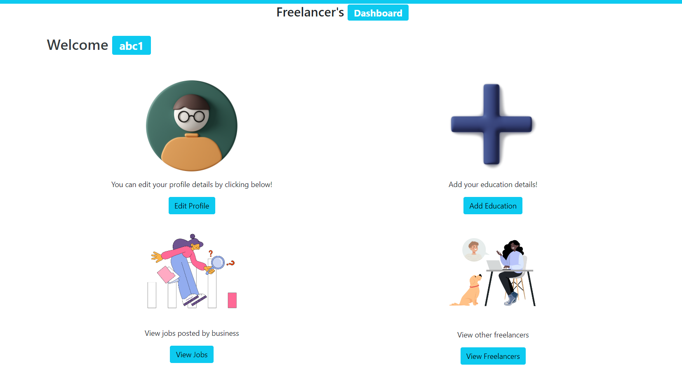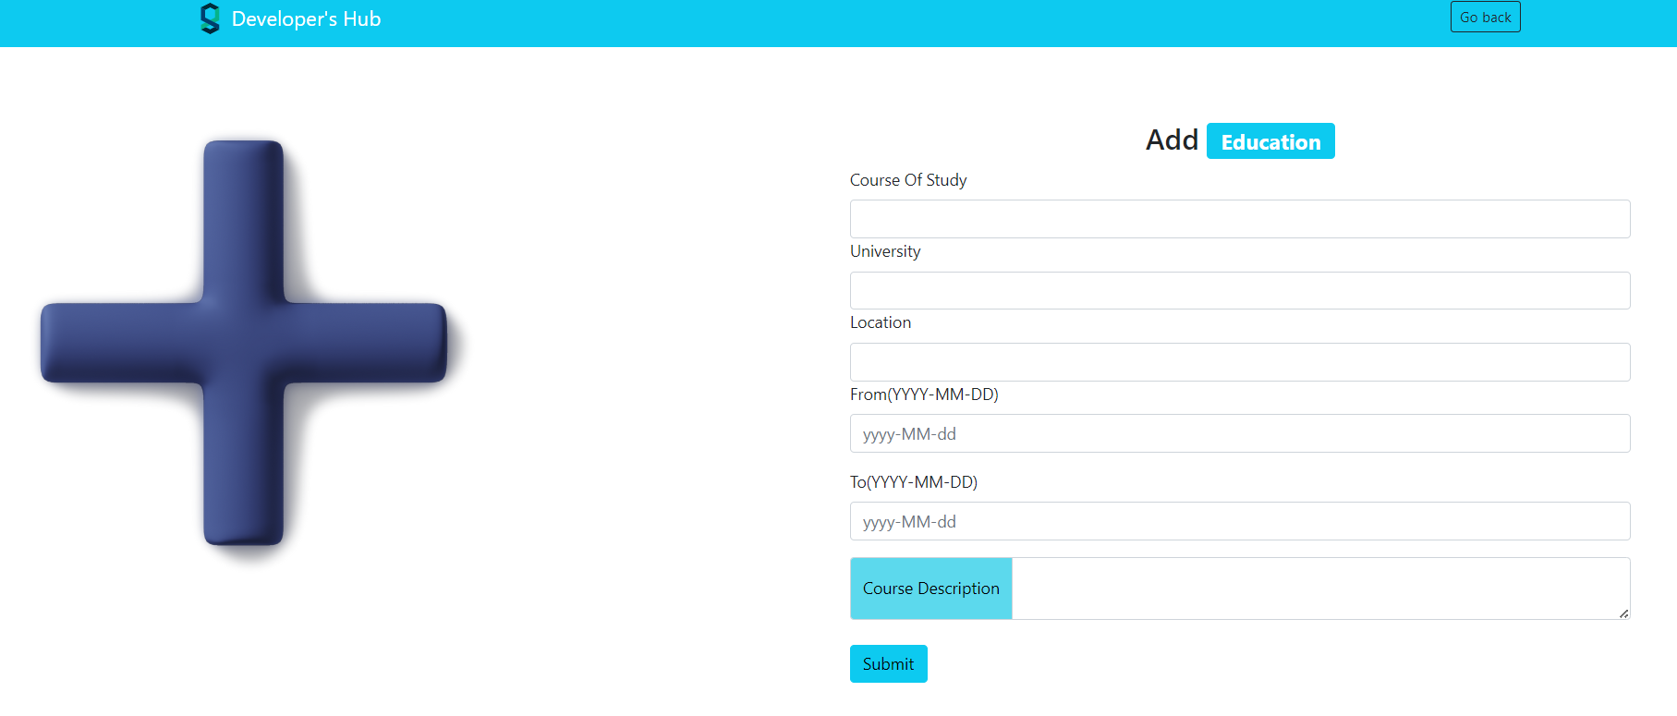

**View all posted job by one ORG : View the interested Freelancer for the job:**

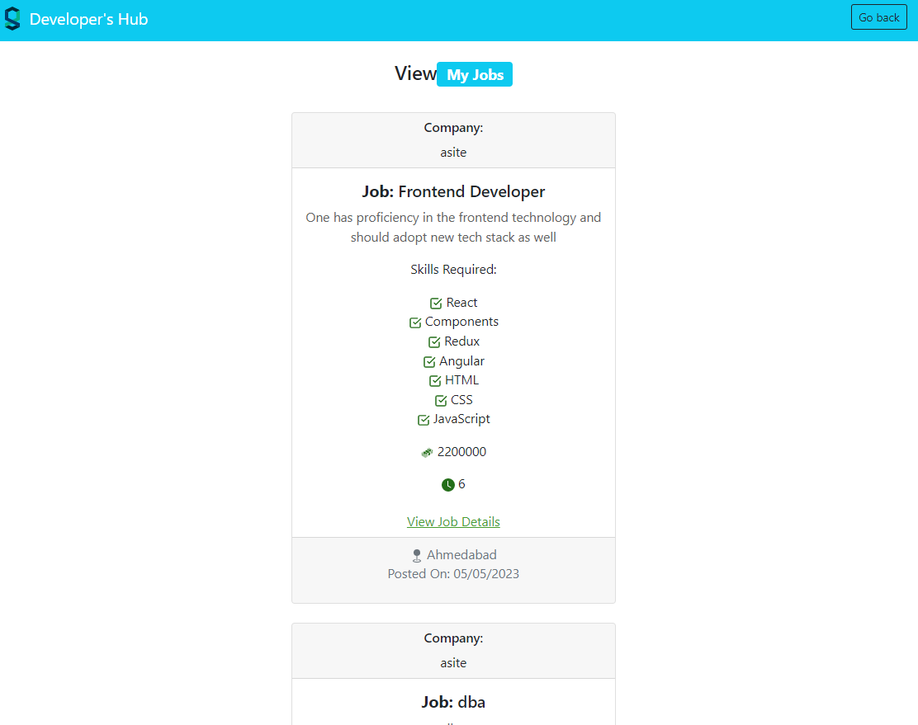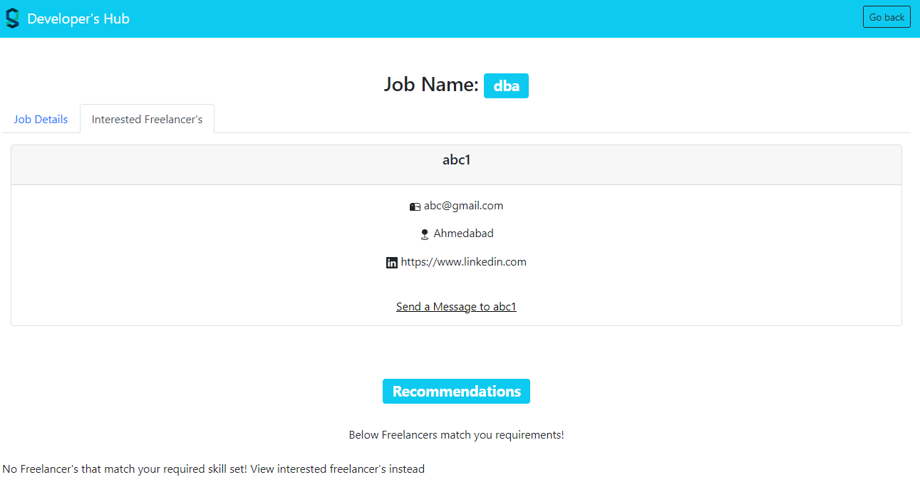

|  |  |  |
| --- | --- | --- |
| **Workflow** | **Functionality** | **Technology stack** |
| Current State | All the basic Functionalities have been implemented, eg. Dashboards, posting jobs, Getting Recommendations, Mailing | React, Redux, Node.js,  Express.js, React-Bootstrap |
| Future Work | Changing Database to SQL server, Implementing chat and video call options between users, chatbot, Filtering options | MS SQL Server, Socket Programming using UDP/TCP Protocol |